MANCOZEB
HPLC method for determining mancozeb in Technical Material and WP formulation
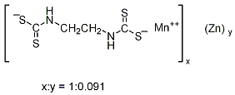

ISO common name | Mancozeb
Chemical compositon | Co-ordination complex of zinc and maneb containing 20% manganese and 2.5% zinc
m.p. | Decomposes
v.p. | Negligible
Solubility | Insoluble in water and most organic solvents
Description | Yellow powder
Stability | Decomposed under acid conditions
Formulation | Wettable powders, water dispersible granules, suspension concentrates and dustable powders

MANCOZEB TECHNICAL
34/TC/M/-

- Sampling. Take at least 200g.

- Identity tests

  - HPLC. Use the reversed phase HPLC method below. The relative retention time of the mancozeb peak in the sample solution should not differ by more than 1.5% from that of the calibration solution (Fig. 1and 2).

  - Infrared. Prepare potassium bromide discs from the sample and from mancozeb standard using 0.7 mg material and 400 mg of potassium bromide. Scan the discs from 4000 to 400cm⁻¹. The spectrum produced from the sample should not differ significantly from that of the standard (Fig. 3).

- Mancozeb.

OUTLINE OF METHOD
The content of Mancozeb is determined by reversed phase HPLC using UV detector and external standardization.

REAGENTS

Mancozeb standard of known content,
Water HPLC Grade
Methanol HPLC grade
Disodium hydrogen phosphate
Sodium hydroxide
Tetrabutyl ammonium hydrogen sulfate
Sodium Sulfite
EDTA

CALIBRATION SOLUTION
- Solution A. Weigh 3.72g EDTA, 1.42g disodium hydrogen phosphate, and 3.39g tetrabutylammonium hydrogen sulfate into a beaker, then add 1000 mL water. Place the beaker in an ultrasonic bath until the sample has been dissolved completely (about 5 min), mixed thoroughly, adjust the pH of the solution to 10.0 with saturated sodium hydroxide solution.
- Solution B. Weigh 7.44 g EDTA, 1.42 g disodium hydrogen phosphate and 3 g sodium sulfite into a baker, then add 1000 mL water. Place the beaker in an ultrasonic bath until the sample has been dissolved completely (about 5 min), mixed thoroughly, adjust the pH of the solution to 11.0 with saturated sodium hydroxide solution.
- Calibration solution. Weigh in duplicate Mancozeb standard containing 40 mg (accurate to 0.1mg) pure Mancozeb accurately into a 100 mL volumetric flask, add solution B (85 mL) and place the flasks in an ultrasonic bath until the sample has been dissolved completely (about 5 min, keep the bath temperature not higher than 15°C). Allow the solutions to back to room temperature, then make up to volume with solution B and mix thoroughly. Transfer 5 mL into 50 mL volumetric flask accurately, make up to volume with solution B and mix thoroughly. Prior to analysis, filter the solutions with 0.22µm filters (Calibration solutions C1 and C2, stable up to 4 hrs after preparation).

APPARATUS

High performance liquid chromatograph equipped with a detector suitable for 282nm, a column oven can control at 15°C and injection system capable of injecting 5μL.
Liquid chromatographic column, Agilent Extend C18（4.6×150mm, 5μm）or equivalent with the same selectivity.
Ultrasonic bath
Filter, 0.22µm
Analytical balance
pH meter

PROCEDURE
(a) Chromatographic conditions (typical)
Column: Agilent Extend C18（4.6×150mm, 5μm）or equivalent
Mobile phase: Solution A- Methanol =70:30 (V/V)
Column Temperature: 15°C
Flow Rate: 1.0ml/min
Detector Wavelength：282nm
Injection Volume: 5μL
Retention time: approximately 7.5min
Run time: 13min
Environment temperature: below 20°C

(b) Equilibration of the system.
Inject 5μL of the calibration solution C1 and repeat the injections until retention times and peak areas deviate by less than 0.5% from the mean for 3 successive injections.

(C) Sample preparation.
Prepare sample solutions in duplicate. Weigh the test item containing around 40mg (accurate to 0.1mg) pure Mancozeb accurately into a 100 mL volumetric flask, add solution B (85 mL) and place the flasks in an ultrasonic bath until the sample has been dissolved completely (about 5 min and keep the bath temperature not higher than 15°C). Allow the solutions to back to room temperature, then make up to volume with solution B and mix thoroughly. Transfer 5 mL into 50 mL volumetric flask accurately, make up to volume with solution B and mix thoroughly. Prior to analysis, filter the solutions with 0.22µm filters (Sample solutions S1 and S2, stable up to 4 hrs after preparation).

(d) Determination.
Inject 5μL of calibration solution C2 for two successive injections. The mean response factor for this solution should deviate by no more than 1% from that of C1 (see section (b), otherwise prepare the calibration solutions again. Inject in duplicate 5μL of each sample bracketing them by duplicates of calibration solution (C1 or C2) using the following sequence: C1 (two injections), S1-1(two injections), S1-2 (two injections), C2 (two injections), S2-1(two injections), S2-2 (two injections), C1 (two injections) …. etc .

(e) Calculation.
Calculate the mean value of each pair of response factors bracketing the two injections of a sample and use this value for calculating mancozeb content of the bracketed sample injections.

$$f_{i}=\frac{s×P}{H_{s}}$$

mancozeb content(X) $=\frac{f×H_{w}}{w}$ g/kg
where:
f_{i} = individual response factor
f = mean response factor of two calibrations before and after the sample
H_{s} = peak area of mancozeb in the calibration solution
H_{w} = peak area of mancozeb in the sample solution
s = mass of mancozeb reference standard in the calibration solution (mg)
w = mass of sample taken (mg)
P = purity of mancozeb reference standard (g/kg)

Repeatability r =9 to 19 g/kg at 850kg/kg active ingredient content
Reproducibility R =15 to 24 g/kg at 850kg/kg active ingredient content

MANCOZEB WETTABLE POWDERS
34/WP/M/-
1. Sampling. Take at least 200 g.

2. Identity tests
2.1 HPLC. As for mancozeb technical 34/TC/M/2.1

2.2 Infrared. As for mancozeb technical 34/TC/M/2.2

3. Mancozeb. As for mancozeb technical 34/TC/M/3

4. Suspensibility
Reagents and apparatus as for 34/TC/M and MT 184

a) Preparation of suspension and determination of sedimentation. MT 184.
b) Determination of Mancozeb in the bottom 25ml of suspension. After removal of the top 225ml suspension transfer the remaining 25ml to a volumetric flask (100ml) and dilute to volume with Solution B [as for 34/TC/M/3/3.5/3.5.2/b)], place the flasks in an ultrasonic bath until the sample has been dissolved completely (about 5 min and keep the bath temperature not higher than 15℃), then do the measurement and calculation in accordance with the analysis of Mancozeb technical method.
c) Calculation
Suspensibility$=\frac{\text{111}(c−Q)}{c}$%

where:
c = mass of mancozeb in the sample taken for the preparation of the suspension (g)
Q = mass of mancozeb in the bottom 25 ml of suspension (g)

Repeatability r =9 to 19 g/kg at 830kg/kg active ingredient content
Reproducibility R = 15to 24 g/kg at 830kg/kg active ingredient content

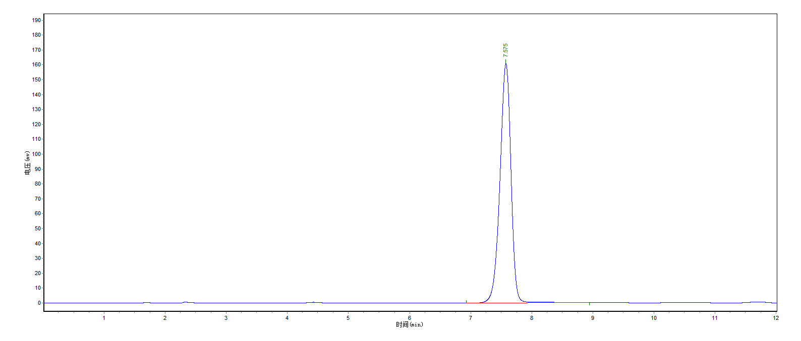 Fig. 1 Chromatogram of Mancozeb standard

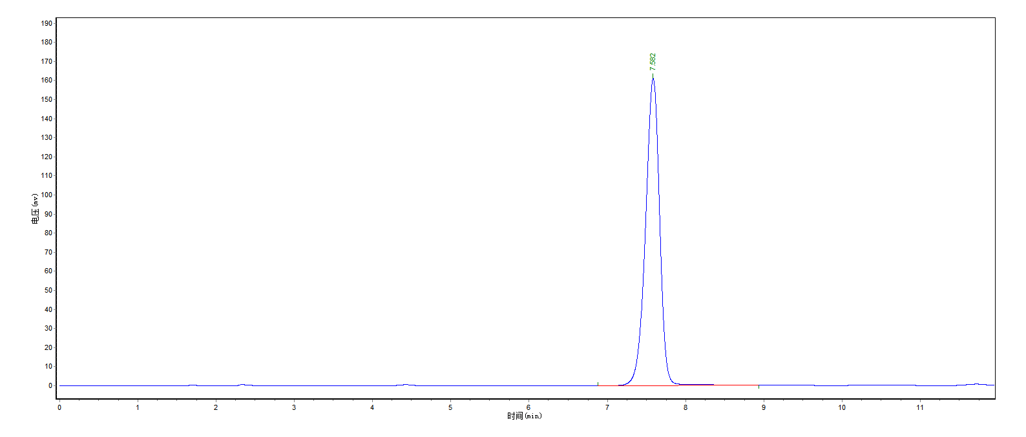
Fig. 2 Chromatogram of Mancozeb TC sample

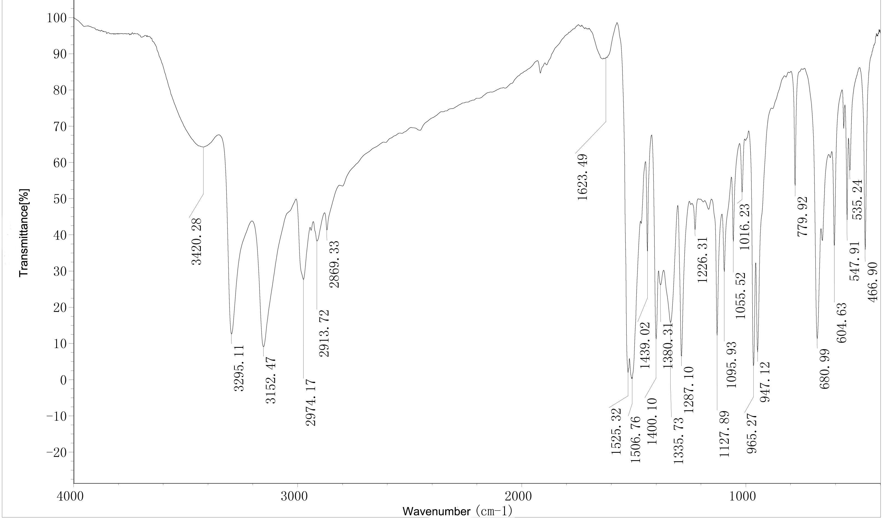

Fig. 3 Infrared spectra of Mancozeb

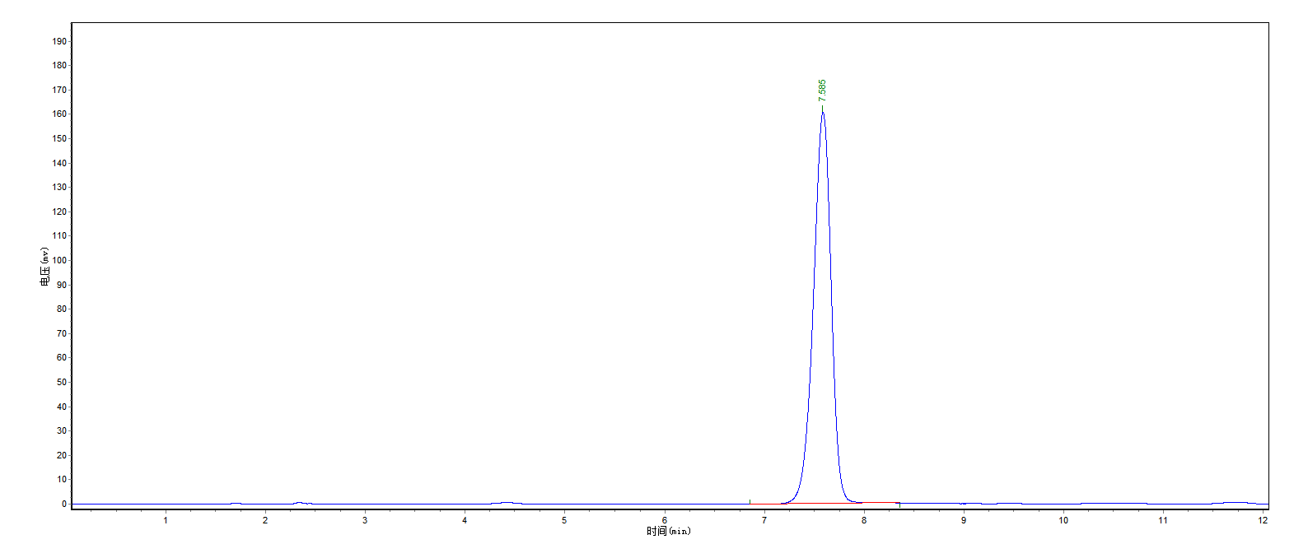
Fig. 4 Chromatogram of Mancozeb WP sample

